MGT 40750 – Quantitative Decision Modeling Spring 2017

**Solution to Assignment 3: Network Models  
Integer and Nonlinear Programming**

There are five questions (15 total points) in this assignment. All relevant Excel files can be found on Sakai. Solve these questions in Excel and fill in the solution template provided below.

**Question 1: Problem 43 on page 268 in the PMS 5th Ed textbook.**

Step 1: Specify the Excel file Question1.xlsx. Make sure to record *all the necessary formulas*.

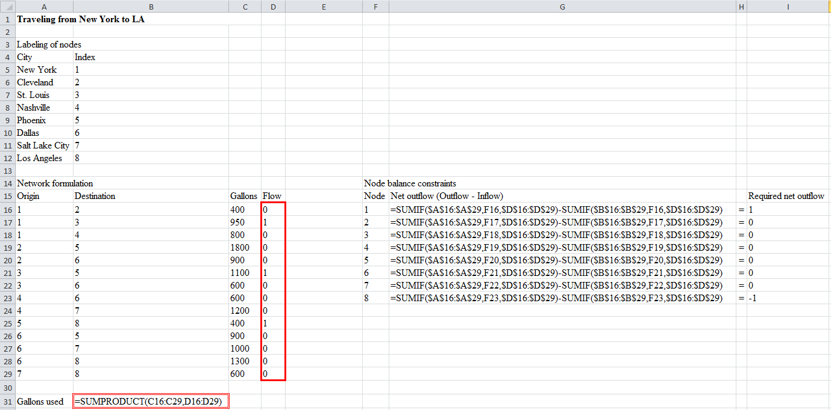

Step 2: Specify Solver

Set Objective: B31

To: ○ Max X Min ○ Value of: _________

By Changing Variable Cells: D16:D29

Subject to the Constraints:

|  |
| --- |
| G16:G23=I16:I23  D16:D29=binary |

□ Make Unconstrained Variables Non-Negative

Select a Solving Method: Simplex LP

Step 3: Report your results below.

The best route is New York (1) 🡪 St. Louis (3) 🡪 Phoenix (5) 🡪 Los Angeles (8).

**Question 2: Problem 49 on page 269 in the PMS 5th Ed textbook.**

Step 1: Specify the Excel file Question2.xlsx. Make sure to record *all the necessary formulas*.

*Hint: Hours Spent cannot go beyond Hours Required.*

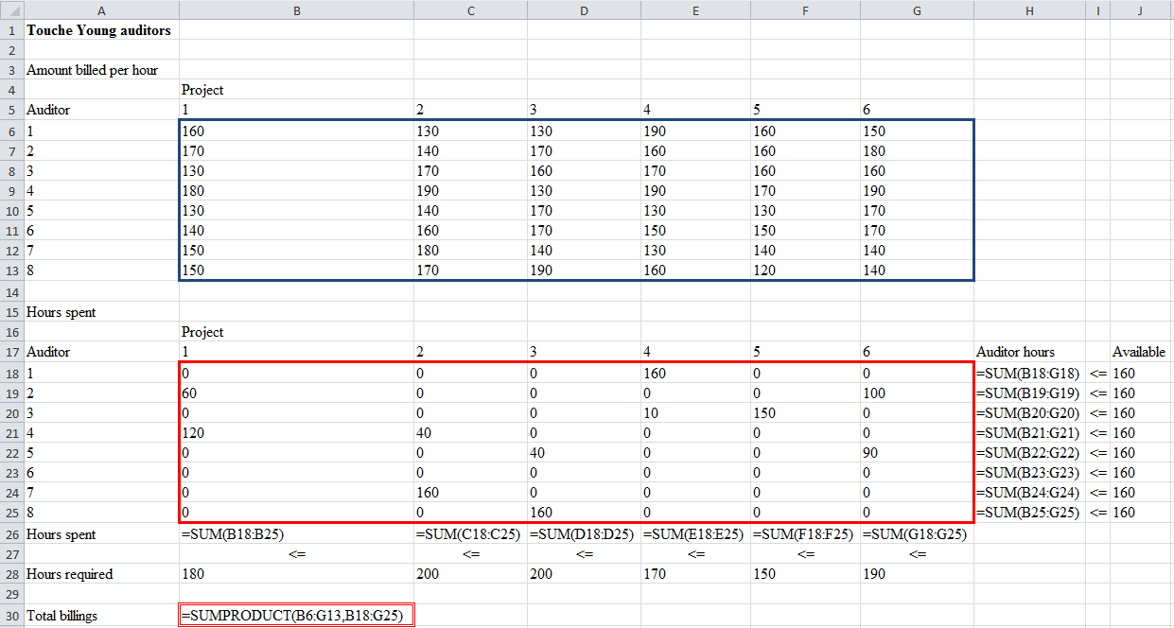

Step 2: Specify Solver

Set Objective: B30

To: X Max ○ Min ○ Value of: _________

By Changing Variable Cells: B18:G25

Subject to the Constraints:

|  |
| --- |
| B26:G26<=B28:G28 (“=” would work too.)  H18:H25<=J18:J25 |

X Make Unconstrained Variables Non-Negative

Select a Solving Method: Simplex LP

Step 3: Report your results below.

The maximal total billings = 194,800.

**Question 3: Problem 43 on page 328 in the PMS 5th Ed textbook.**

Step 1: Specify the Excel file Question3.xlsx. Make sure to record all the necessary formulas.

|  |
| --- |
|  |

Step 2: Specify Solver

Set Objective: B32

To: X Max ○ Min ○ Value of: _________

By Changing Variable Cells: B14:H14

Subject to the Constraints:

|  |
| --- |
| B14:H14=binary  B18:B20>=D18:D20  B24:B26>=D24:D26  B30>=D30  I14=K14 |

□ (doesn’t matter) Make Unconstrained Variables Non-Negative

Select a Solving Method: Simplex LP

Step 3: Report your results below.

The optimal total defensive ability of the starting team = 10.

**Question 4: Problem 70 on page 331 in the PMS 5th Ed textbook.**

*Hints:*

* *Suppose the capacity of each shift is 10,000. Then the effective capacity of each shift is either 10,000 if the shift is run, or 0 if the shift is not run.*
* *Use B13:E13,B15:E15 as decision variables.*

**Part a.**

Step 1: Specify the Excel file Question4.xlsx. Make sure to record all the necessary formulas.

|  |
| --- |
|  |

Step 2: Specify Solver

Set Objective: B26

To: ○ Max X Min ○ Value of: _________

By Changing Variable Cells: B13:E13,B15:E15

Subject to the Constraints:

|  |
| --- |
| B13:E13=binary  B15:E15<=B17:E17  B19:E19>=B21:E21 |

X Make Unconstrained Variables Non-Negative (*This needs to be checked because “Quantity Produced” has to be nonnegative.*)

Select a Solving Method: Simplex LP

Step 3: Report your results below.

Optimal production schedule:

|  |  |  |  |  |
| --- | --- | --- | --- | --- |
|  | Day 1 | Night 1 | Day 2 | Night 2 |
| Run shift | 1 | 1 | 0 | 1 |
| Quantity produced | 2,000 | 5,000 | 0 | 3,000 |

The optimal total cost = 19,000.

**Part b. Report your updated results below.**

Optimal production schedule:

|  |  |  |  |  |
| --- | --- | --- | --- | --- |
|  | Day 1 | Night 1 | Day 2 | Night 2 |
| Run shift | 1 | 0 | 1 | 0 |
| Quantity produced | 5,000 | 0 | 5,000 | 0 |

The optimal total cost = 8,000.

Is it reasonable that the decrease in setup costs has actually raised the average inventory level? Explain.

Yes, it is reasonable. The day shift setup decrease is so large that it is now best to produce only during day shifts, even though this entails more inventory carried from day to night.

**Question 5: Problem 62 on page 403 in the PMS 5th Ed textbook (just do part a).**

Step 1: Specify the Excel file Question5.xlsx. Make sure to record all the necessary formulas.

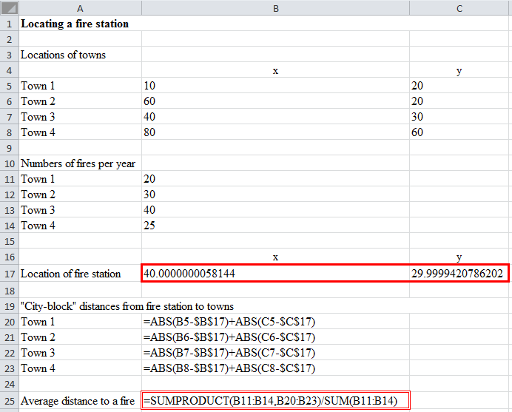

Step 2: Specify Solver

Set Objective: B25

To: ○ Max X Min ○ Value of: _________

By Changing Variable Cells: B17:C17

Subject to the Constraints:

|  |
| --- |
| (No constraints) |

□ Make Unconstrained Variables Non-Negative

Select a Solving Method: GRG Nonlinear

Step 3: Report your results below.

|  |  |  |
| --- | --- | --- |
|  | x | y |
| Location of fire station | 40 | 30 |

The optimal average distance to a fire = 30.